GYM WEBSITE

Web Development Project

Under Guidance of – Sir Nitesh Kumar

Name- Shivam Verma

Registration number – 12222155

Section- KOC35

Roll no- 55

**Technologies Used**

**🡪HTML**

The **Hyper Text Markup Language** or **HTML** is the standard markup language for documents designed to be displayed in a web browser. It can be assisted by technologies such as Cascading Style Sheets (CSS) and scripting languages such as JavaScript.

Web browsers receive HTML documents from a web server or from local storage and render the documents into multimedia web pages. HTML describes the structure of a web page semantically and originally included cues for the appearance of the document.

HTML elements are the building blocks of HTML pages. With HTML constructs, images and other objects such as interactive forms may be embedded into the rendered page. HTML provides a means to create structured documents by denoting structural semantics for text such as headings, paragraphs, lists, links, quotes, and other items. HTML elements are delineated by *tags*, written using angle brackets. Tags such as <img> and <input> directly introduce content into the page. Other tags such as <p> surround and provide information about document text and may include other tags as sub-elements. Browsers do not display the HTML tags but use them to interpret the content of the page.

🡪**CSS**

**Cascading Style Sheets** (**CSS**) is a style sheet language used for describing the presentation of a document written in a markup language such as HTML or XML (including XML dialects such as SVG, MathML or XHTML). CSS is a cornerstone technology of the World Wide Web, alongside HTML and JavaScript.

CSS is designed to enable the separation of content and presentation, including layout, colors, and fonts. This separation can improve content accessibility; provide more flexibility and control in the specification of presentation characteristics; enable multiple web pages to share formatting by specifying the relevant CSS in a separate .css file, which reduces complexity and repetition in the structural content; and enable the .css file to be cached to improve the page load speed between the pages that share the file and its formatting.

**🡪Java Script**

**JavaScript**, often abbreviated as **JS**, is a programming language that is one of the core technologies of the World Wide Web, alongside HTML and CSS. As of 2022, 98% of websites use JavaScript on the client side for webpage behavior, often incorporating third-party libraries. All major web browsers have a dedicated JavaScript engine to execute the code on users' devices.

JavaScript is a high-level, often just-in-time compiled language that conforms to the ECMAScript standard. It has dynamic typing, prototype-based object-orientation, and first-class functions. It is multi-paradigm, supporting event-driven, functional, and imperative programming styles. It has application programming interfaces (APIs) for working with text, dates, regular expressions, standard data structures, and the Document Object Model (DOM).

About project

Title—

Gym website—

Objective –

In THIS PROJECT I HAVE TO DEVELOP A ONLINE GYM WEBSITE WHICH GIVES INFORMATION ABOUT THE THINGS AVAILABLE IN GYM , TIMING ,CONTACTS ,PHOTO GALLERY ,REVIEWS.

DESCRIPTION—

I HAD MADE THIS PROJECT WITH THE HELP OF HTML ,CSS AND JAVASCRIPT.

SOME SNAPSHOTS—

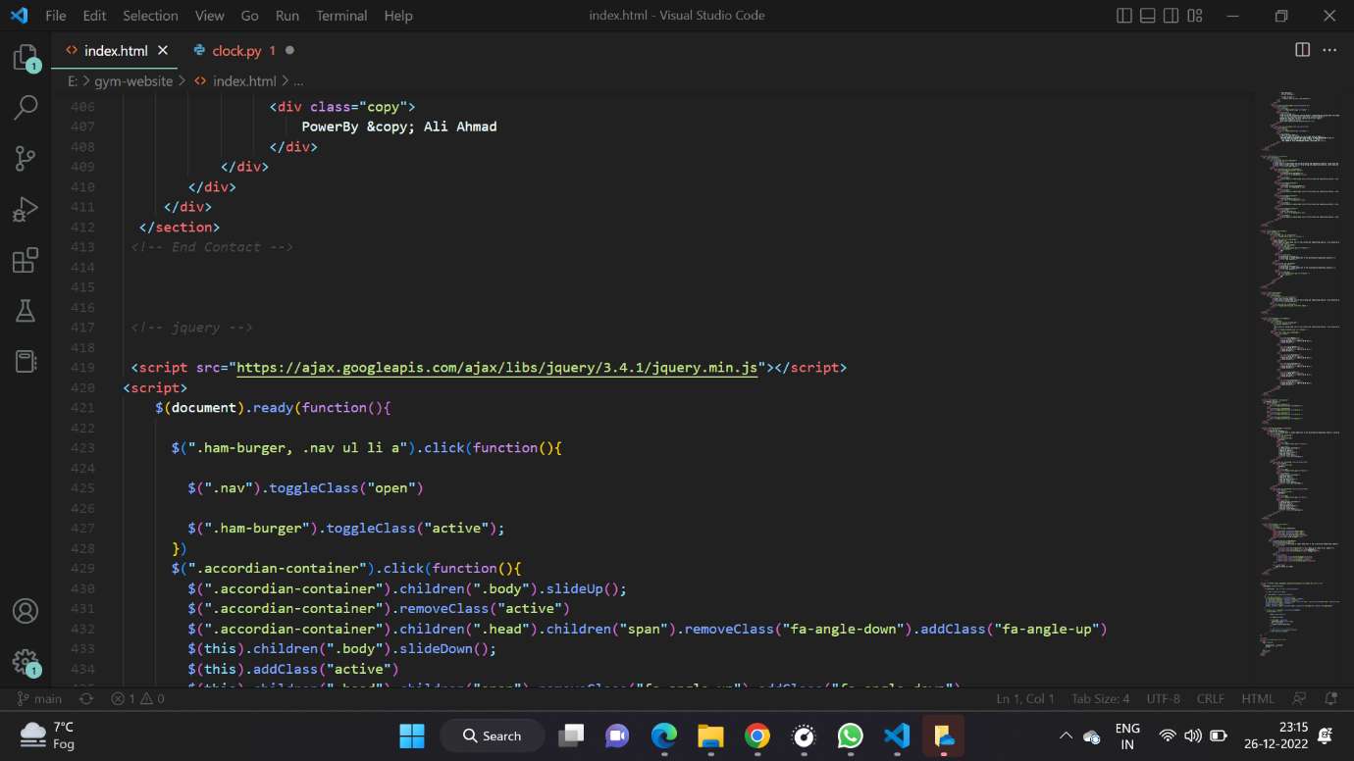

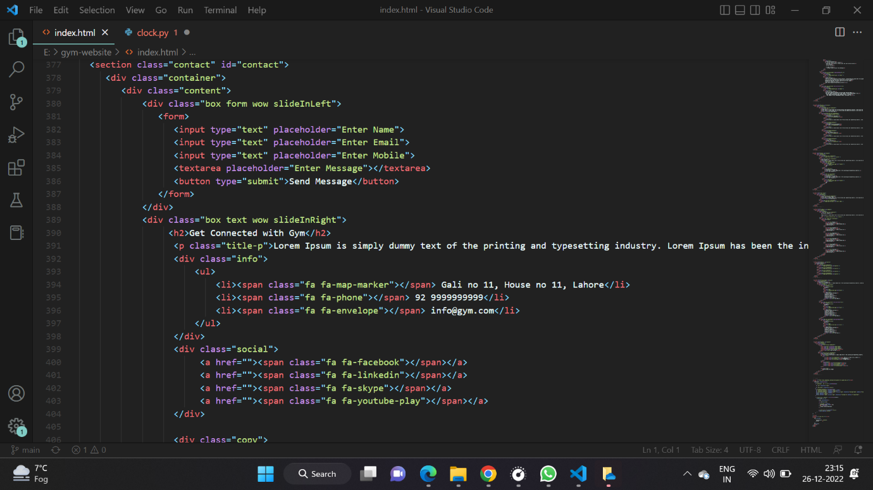

Some images used—

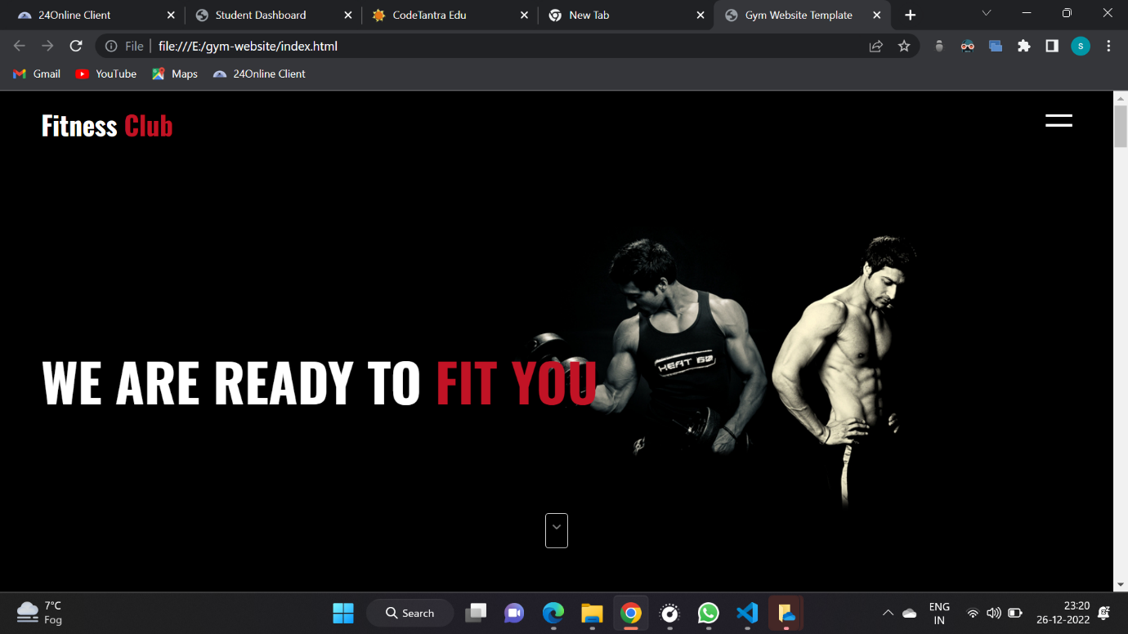

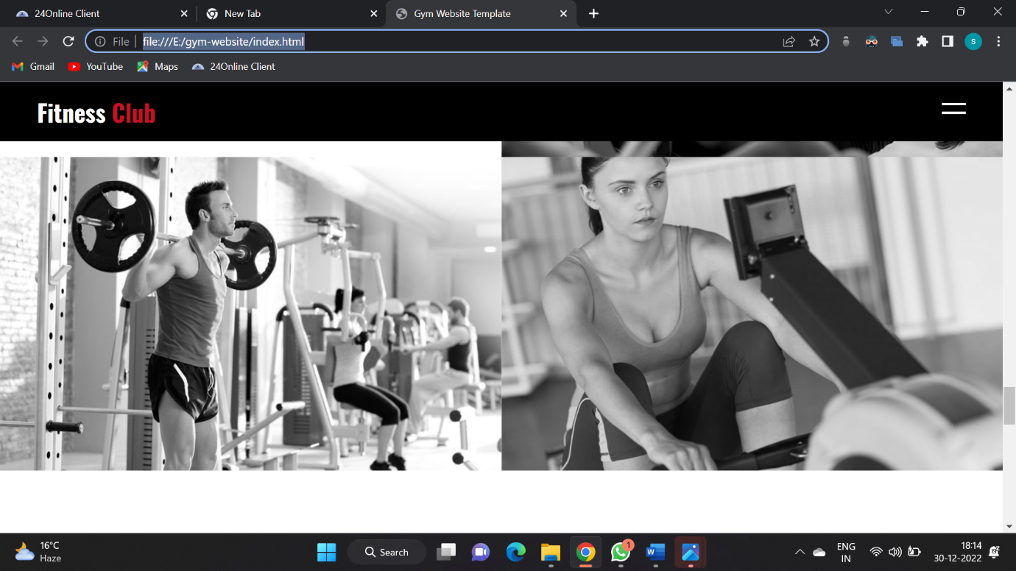

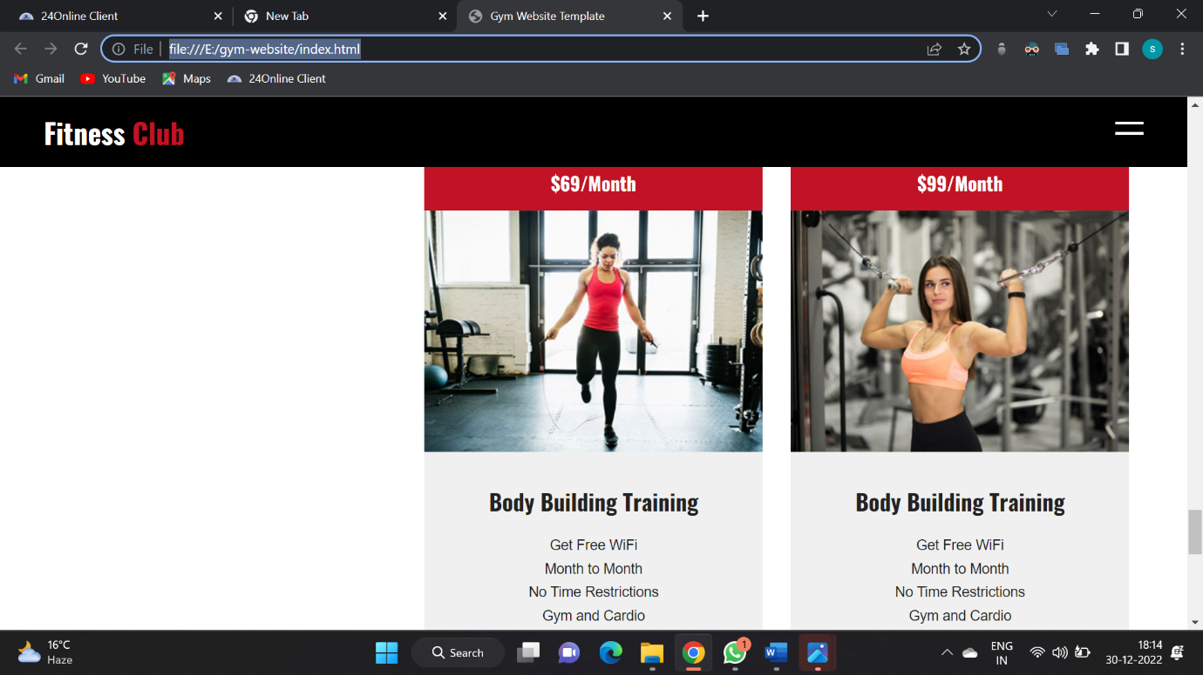

Visit following link for more—

https://github.com/radhey2003/Shivam_WEB-TECHNOLOGY_KOC35_CIPHERSCHOOL